# PROFESSIONAL TRAINING REPORT

**at**

**Sathyabama Institute of Science and Technology**

**(Deemed to be University)**

Submitted in partial fulfillment of the requirements for the award of Bachelor of Engineering Degree in Computer Science and Engineering

By

## MANEPALLI VIJAYA VARDHAN

**REG.NO. 40110721**



**DEPARTMENT OF COMPUTER SCIENCE AND ENGINEERING SCHOOL OF COMPUTING**

**SATHYABAMA INSTITUTE OF SCIENCE AND TECHNOLOGY JEPPIAAR NAGAR, RAJIV GANDHI SALAI,**

**CHENNAI – 600119, TAMILNADU**

**NOVEMBER 2022**

**SATHYABAMA**

**INSTITUTE OF SCIENCE AND TECHNOLOGY**

### (DEEMED TO BE UNIVERSITY)

**Accredited with Grade “A” by NAAC**

**(Established under Section 3 of UGC Act, 1956)**

**JEPPIAAR NAGAR, RAJIV GANDHI SALAI, CHENNAI– 600119**

**[www.sathyabamauniversity.ac.in](http://www.sathyabamauniversity.ac.in/)**

# DEPARTMENT OF COMPUTER SCIENCE AND ENGINEERING

**BONAFIDE CERTIFICATE**

This is to certify that this Project Report is the bonafide work of **MANEPALLI VIJAYA VARDHAN (40110721)** who carried out the project entitled “**Online Shopping for Wood Works**” under my supervision from Aug 2022 to Oct 2022.

## Internal Guide

## MRS. KARTHIKA

**Head of the Department**

**Dr.L.Lakshmanan M.E., Ph.D.**



## Submitted for Viva voce Examination held on

**InternalExaminer ExternalExaminer**

**DECLARATION**

I, **MANEPALLI VIJAYA VARDHAN** hereby declare that the Project Report entitled “**Online Shopping for Wood Works”** done by me under the guidance of **MRS. KARTHIKA** is submitted in partial fulfillment of the requirements for the award of Bachelor of Engineering degree in Computer Science and Engineering.

## DATE: 08-11-2022

**PLACE: Chennai**

**SIGNATURE OF THE CANDIDATE**

**ACKNOWLEDGEMENT**

I am pleased to acknowledge my sincere thanks to **Board of Management** of **SATHYABAMA** for their kind encouragement in doing this project and for completing it successfully. I am grateful to them.

I convey my thanks to **Dr. T. Sasikala M.E., Ph.D.**, **Dean**, School of Computing , **Dr.S.Vigneshwari M.E., Ph.D., and Dr.L.Lakshmanan M.E., Ph.D.,** Heads of the Department of Computer Science and Engineering for providing me necessary support and details at the right time during the progressive reviews.

I would like to express my sincere and deep sense of gratitude to my Project Guide **MRS. KARTHIKA** for her valuable guidance, suggestions and constant encouragement paved way for the successful completion of my project work.

I wish to express my thanks to all Teaching and Non-teaching staff members of

the **Department of Computer Science and Engineering** who were helpful in

many ways for the completion of the project.

**ABSTRACT**

This project is a web based shopping system for an existing shop. The project objective is to deliver the online shopping application into android platform.

This project is an attempt to provide the advantages of online shopping to customers of a real shop. It helps buying the products in the shop anywhere through internet by using an android device. Thus the customer will get the service of online shopping and home delivery from his favorite shop. This system can be implemented to any shop in the locality or to multinational branded shops having retail outlet chains.

If shops are providing an online portal where their customers can enjoy easy shopping from anywhere, the shops won’t be losing any more customers to the trending online shops. Since the application is available in the smartphone it is easily accessible and always available.

An online shopping system that permits a customer to submit online orders for items and/or services from a store that serves both walk-in customers and online customers. The online shopping system presents an online display of an order cut off time and an associated delivery window for items selected by the customer.

The system accepts the customer's submission of a purchase order for the item in response to a time of submission being before the order cut off time. The online shopping system does not settle with a credit supplier of the customer until the item selected by the customer is picked from inventory but before it is delivered. Therefore, the customer can go online and make changes to the order.

In addition, available service windows are presented to the customer as a function of customer selected order and service types and further, the order picking is assigned in accordance with a picker's preference. When ordering goods, many shopping systems provide a virtual shopping cart for holding items selected for purchase. Successive items selected for purchase are placed into the virtual shopping cart until a customer completes their shopping trip. Virtual shopping carts may be examined at any time, and their contents can be edited or deleted at the option of the customer. Once the customer decides to submit a purchase order, the customer may print the contents of the virtual shopping basket in order to obtain a hard copy record of the transaction.

**LIST OF FIGURES**

* 1. ADMIN MODULE
  2. MANAGE MODERATORS
  3. MANAGE PRODUCTS
  4. MANAGE USERS
  5. MANAGE ORDERS
  6. MODERATOR MODULE
  7. USER MODULE

**TABLE OF CONTENTS**

|  |  |  |
| --- | --- | --- |
| **CHAPTER No.** | **TITLE** | **PAGE No.** |
|  | ABSTRACT | i |
|  | LIST OF FIGURES | ii |
| **1** | **INTRODUCTION** | **1** |
|  | 1.1 PROJECT OBJECTIVES |  |
|  | 1.2 PROJECT OVERVIEW |  |
|  | 1.3 PROJECT SCOPE |  |
|  | 1.4 STUDY OF THE SYSTEM |  |
| **2** | **SYSTEM ANALYSIS** |  |
|  | 2.1 EXISTING SYSTEM |  |
|  | 2.2 PROPOSED SYSTEM |  |
|  | 2.3 SYSTEM REQUIREMENT SPECIFICATION |  |
|  | 2.3.1 GENERAL DESCRIPTION |  |
|  | 2.3.2 SYSTEM OBJECTIVES |  |
|  | 2.3.3 SYSTEM REQUIREMENTS |  |
|  | 2.3.3.1 NON FUNCTIONAL REQUIREMENT |  |
|  | 2.3.3.2 FUNCTIONAL REQUIREMENT |  |
| **3** | **SYSTEM DESIGN** |  |
|  | 3.1 INPUT AND OUTPUT DESIGN |  |
|  | 3.1.1 INPUT DESIGN |  |
|  | 3.1.2 OUTPUT DESIGN |  |
|  | 3.2 SYSTEM TOOLS |  |

**CHAPTER-1 INTRODUCTION**

This project is a web based shopping system for an existing shop. The project objective is to deliver the online shopping application into android platform.

Online shopping is the process whereby consumes directly buy goods or services from a seller in real-time, without an intermediately service, over the internet. It is a form of electronic commerce. This project is an attempt to provide the advantages of online shopping to customers of a real shop. It helps buying the products in the shop anywhere through internet by using an android device. Thus the customer will get the service of online shopping and home delivery from his favorite shop.

* 1. **PROJECT OBJECTIVE**

The objective of the project is to make an application in android platform to purchase items in an existing shop. In order to build such an application complete web support need to be provided. A complete and efficient web application which can provide the online shopping experience is the basic objective of the project. The web application can be implemented in the form of an android with web view.

**1.2 PROJECT OVER VIEW**

The central concept of the application is to allow the customer to shop virtually using the internet and allow customers to buy the items and articles of their desire from the store.

The server process the customers and the items are shipped to the address submitted by them. The application was designed into two modules first is for the customers who wish to buy the articles. Second is for the storekeepers who maintains and updates the information pertaining to the articles and those of the customers. The end user of this product is a departmental store where the application is hosted on the web and the administrator maintains the database. The application which is deployed at the customer database, the details of the items are brought forward from the database for the customer view based on the selection through the menu and the database of all the products are updated at the end of each transaction. Data entry into the application can be done through various screens designed for various levels of users. Once the authorized personnel feed the relevant data into the system, several reports could be generated as per the security.

**1.3 PROJECT SCOPE**

This system can be implemented to any shop in the locality or to multinational branded shops having retail outlet chains. The system recommends a facility to accept the orders 24*7 and a home delivery system which can make customers happy.

If shops are providing an online portal where their customers can enjoy easy shopping from anywhere, the shops won’t be losing any more customers to the trending online shops. Since the application is available in the smartphone it is easily accessible and always available.

**COMPONENTS**

1. AmountButton.jsx
2. Cart.css
3. CartList.jsx
4. Filters.css
5. Footer.jsx
6. Loading.jsx
7. Navbar.jsx
8. Navbar.modules.css
9. Product.jsx
10. ProductImages.jsx
11. Product.modules.css
12. Single.modules.css
13. singleProductComponent.jsx
14. StripeForm.jsx
15. Totals.jsx

**1.4 STUDY OF THE SYSTEM**

**1.4.1 MODULES:**

The system after careful analysis has been identified to be presented with the following modules and roles.

The modules involved are:

* Administrator
* Moderators
* Users

**1.4.1.1 Administrator:**

The administrator is the super user of this application. Only admin have access into this admin page. Admin may be the owner of the shop. The administrator has all the information about all the users and about all products.

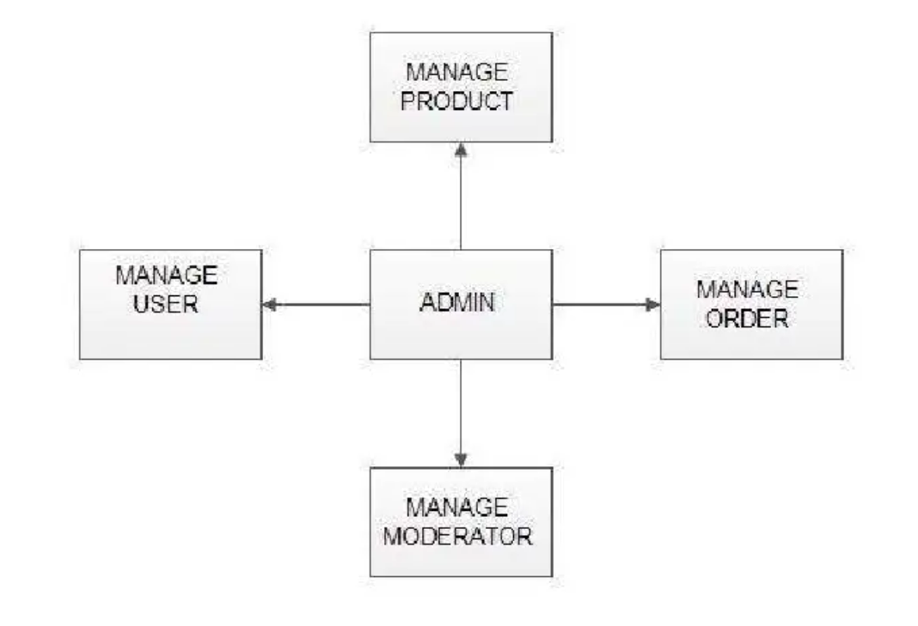

Fig 1.1 Admin Module

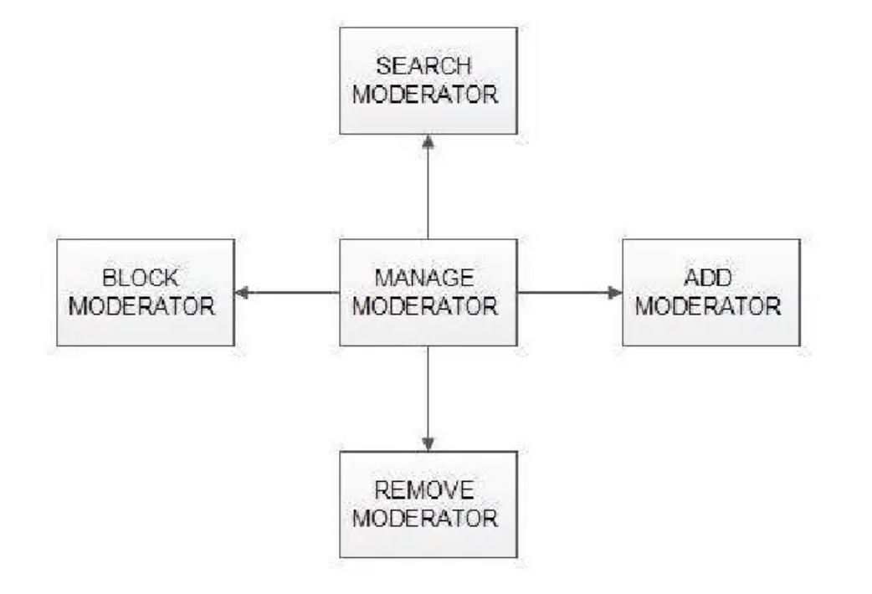

Fig 1.2 Manage Moderator

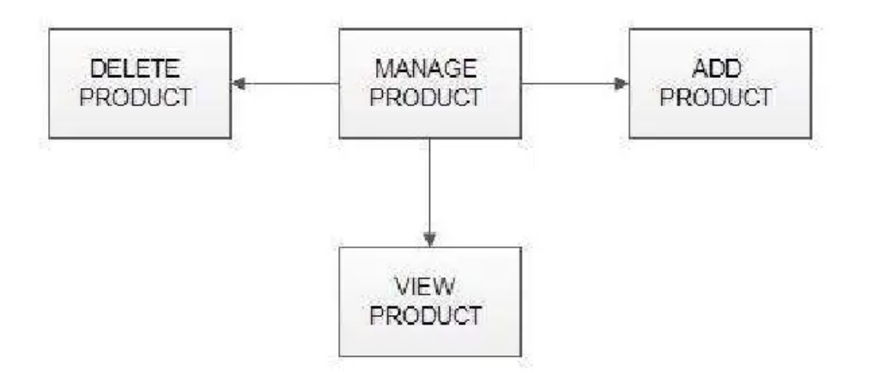

Fig 1.3 Mange Products

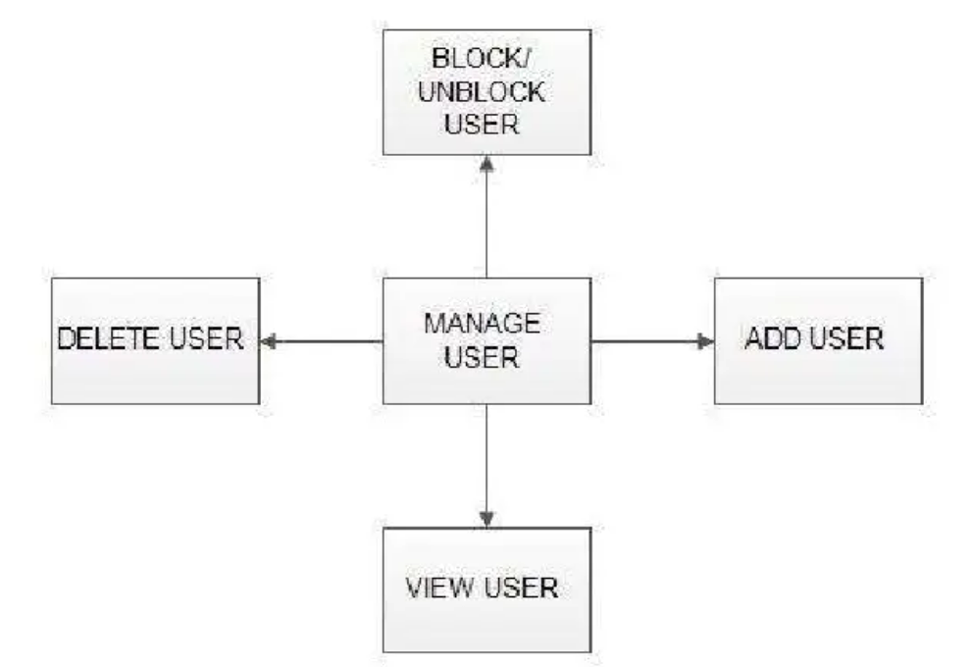

Fig 1.4 Manage User

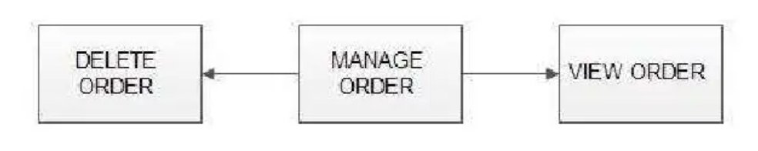

Fig 1.5 Manage Orders

**1.4.1.2 Moderators:**

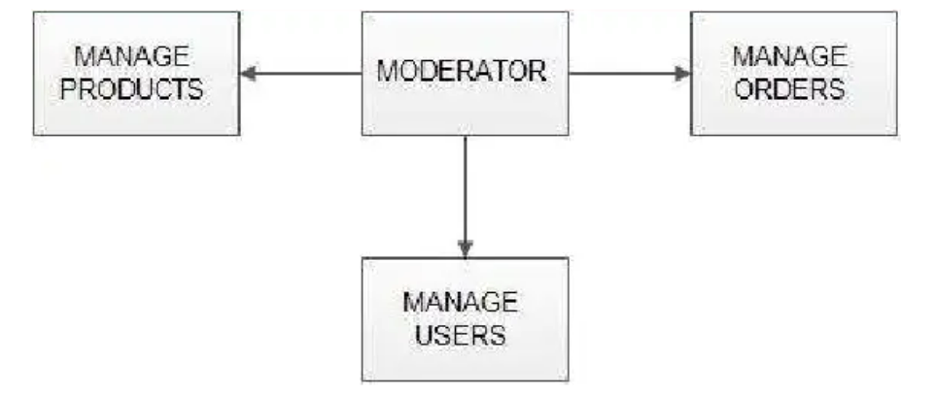

Fig 1.6 Moderator Module

A moderator is considered as a staff who can manage orders for the time being. As a future update moderator give facility to add and manage his own products. Moderators can reduce the work load of admin. Now moderator has all the privilege an admin having except managing other moderators. He can add products and users. He can also check the orders and edit his profile.

* Manage products
* Manage users
* Manage orders

**1.4.1.3 USERS**

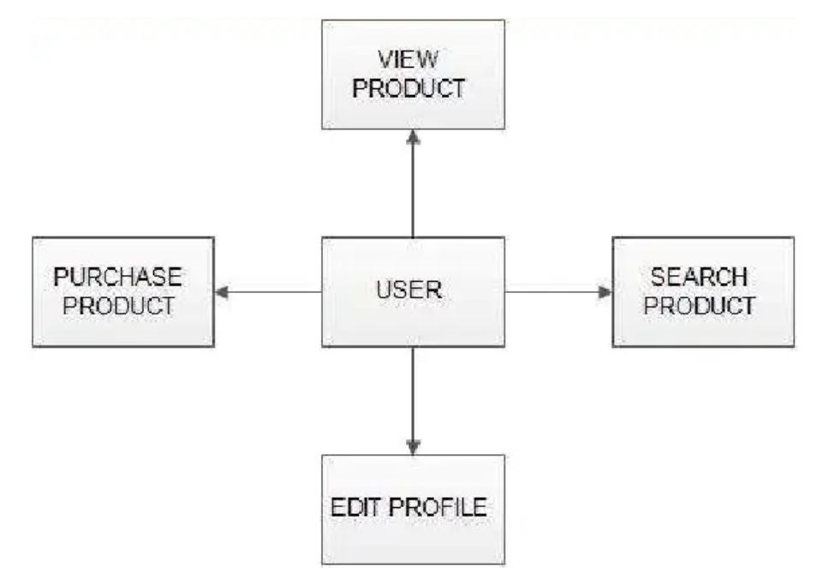

Fig 1.7 User module

**CHAPTER-2 SYSTEM ANALYSIS**

System analysis is the process of gathering and interpreting facts, diagnosing problems and using the information to recommend improvements on the system. System analysis is a problem solving activity that requires intensive communication between the system users and system developers.

**2.1 EXISTING SYSTEM**

The current system for shopping is to visit the shop manually and from the available products choose the item customer want and buying the item by payment of the price of the item.

1. It is less user-friendly.
2. User must go to shop and select products.
3. It is difficult to identify the required product.
4. Description of the product limited.
5. It is a time consuming process.
6. Not in reach of distant users.

**2.2 PROPOSED SYSTEM**

In the proposed system customer need not go to the shop for buying the products. He can order the product he wish to buy through the application in his smartphone. The shop owner will be admin of the system. Shop owner can appoint moderators who will help owner in managing the customers and product orders. The system also recommends a home delivery system for the purchased products.

**2.3 SYSTEM REQUIREMENT SPECIFICATION**

**2.3.1 GENERAL DESCRIPTION**

Product Description:

The system consists of two parts. A web application which can provide the online shopping service and an android application for the customer to access the web service from his smartphone. Web application should be able to help the customer for selecting his item and to help the owner in managing the orders from the customers.

**2.3.2 SYSTEM OBJECTIVES**

* To provide an android application for online shopping of products in an existing shop.
* To provide a online shopping web site for the same shop.

**2.3.3 SYSTEM REQUIREMENTS**

***2.3.3.1 NON FUNCTIONAL REQUIREMENTS:***

1. EFFICIENCY REQUIREMENT
2. RELIABILITY REQUIREMENT
3. USABILITY REQUIREMENT
4. IMPLEMENTATION REQUIREMENT
5. DELIVERY REQUIREMENT

***2.3.3.2 FUNCTIONAL REQUIREMENTS:***

**USER:**

* USER LOGIN
* REGISTER NEW USER
* PURCHASING AN ITEM

**ADMIN:**

* MANAGE USER
* MANAGE MODERATOR
* MANAGE PRODUCTS
* MANAGE ORDERS

**MODERATOR:**

A moderator is considered as a staff who can manage orders for the time being. As a future update moderator may give facility to add and manage his own products. Moderators can reduce the work load of admin. Now moderator has all the privilege of an admin having except managing other moderators. He can manage users and manage products. He can also check the orders and edit his profile.

**CHAPTER-3 SYSTEM DESIGN**

System design is the solution for the creation of a new system. This phase focuses on the detailed implementation of the feasible system. It emphasis on translating design. Specifications to performance specification. System design has two phases of development.

* Logical design
* Physical design

**3.1 INPUT AND OUTPUT DESIGN**

**3.1.1 INPUT DESIGN:**

Input design is the link that ties the information system into the world of its users. The input design involves determining the inputs, validating the data, minimizing the data entry and provides a multi-user facility. Inaccurate inputs are the most common cause of errors in data processing

**3.1.2 OUTPUT DESIGN:**

Computer output is the most important and direct source of information to the user. Output design is a very important phase since the output needs to be in an efficient manner. Efficient and intelligible output design improves the system relationship with the user and helps in decision making.

**3.2 SYSTEM TOOLS**

1. HTML (Hyper Text Markup Language)
2. CSS (Cascading Style Sheets)
3. Java script
4. React JS
5. AuthO